 | Registered Charity Number: 514610

Midland Geotechnical Society
Meeting Notice
 | www.midlandgeotechnicalsociety.org.uk
Thank you to the Sponsors of the Society for their Support:  Patron Sponsors  Aecom  Applied Geology  Arcadis  Arup  Igne  Geotechnics  Huesker  WSP  Supporting Sponsors  GIP Ltd  M&J Drilling Services  Cundall  Mott MacDonald  Contact Us  Honorary Secretary: Scott O’Neill-Gwilliams  scott.oneill@mottmac.com  Tel: 07813029164  Meeting Venue  University of Birmingham, Engineering Building (Y3)  Refreshments 6-6.30pm Room G37  Talk 6.30-8.00pm Lecture Theatre G34  The lecture will be recorded and made available via the members area of the website.  Thank you to the Sponsors of the Society for their Support:  Patron Sponsors  Aecom  Applied Geology  Arcadis  Arup  Igne  Geotechnics  Huesker  WSP  Supporting Sponsors  GIP Ltd  M&J Drilling Services  Cundall  Mott MacDonald  Contact Us  Honorary Secretary: Scott O’Neill-Gwilliams  scott.oneill@mottmac.com  Tel: 0121 2148194  Meeting Venue  University of Birmingham, Engineering Building (Y3)  Refreshments 6-6.30pm Room G37  Talk 6.30-8.00pm Lecture Theatre G31  The lecture will be recorded and made available via the members area of the website. | This lecture has been supported by sponsorship from:
  
  Monday 2nd March 2026
  Chalk Earthworks: past, present and future
  Alan Phear, ARUP
  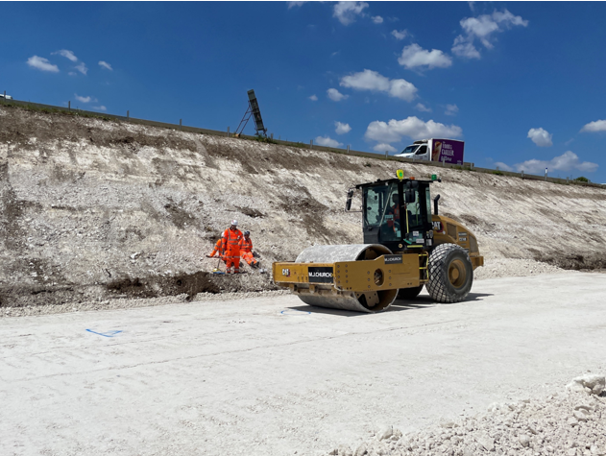
  Abstract
  There is a very long history of building chalk earthworks. For example, Maiden Castle in Dorset, an Iron Age hillfort, was built with hand tools over 2,000 years ago; and masses of chalk fill railway embankments were built mainly by hand in the 19th century.
  Since the 1930s, chalk fill has been constructed using machinery. This dramatically improved efficiency and productivity but also introduced new challenges. Historically, there has been much misunderstanding as to how best to characterise chalk for use as earthworks fill. There has been a lot of research effort in the UK and France over the last 60 years to better understand this.
  Earthworks construction with fill derived from very low, low and low to medium density chalk is different to most other earthworks materials because it breaks down during excavation and compaction, sometimes to a low strength putty which can be difficult to traffic. It then recements and regains strength with time. On the other hand, medium and high density chalk behaves more like other typical earthworks materials and breaks down much less during handling.
  The way that the construction of chalk earthworks is carried out has changed dramatically over the last 20 years or so. This is largely for reasons of construction expediency but also due to the impacts of climate change. Quicklime, cement and other binders are increasingly used to treat very low and low-density chalk, to expedite earthworks construction.
  The use of earthworks to help mitigate the impact of projects mainly for visual and noise reasons, and also to assist with providing net increases in biodiversity, has increased greatly in the last 20 years. This trend will continue due to the requirements of Biodiversity Net Gain legislation introduced in the UK in 2025.
  This talk will discuss many of these themes.
  Speaker
  Alan Phear is an Associate Director and Geotechnical Adviser with Arup and is their global earthworks skills leader. He is currently involved in updating industry guidance on engineering in chalk.
  Alan has many decades of expertise and experience in the design, planning and construction of earthworks for roads, railways, airports and other major infrastructure projects, with a particular interest in chalk earthworks. He is one of the UK’s technical experts on the CEN Committee who developed EN 16907, the European standard on earthworks, and are currently preparing a European standard on sustainable earthworks.
  This meeting is in person at the University of Birmingham. Details to the left.
  MGS Season 2025-26 Events and Lectures:
  Day | Date | Speaker | Title | Location
  Mon | 2nd Mar | Alan Phear  Arup | Les Nichol Award Lecture | Uni of Birm
  Mon | 13th Apr | Ian Webber Coffey Geotechnics | Concept Design: The Repurposing of Cigarette Packets | Uni of Birm
  Mon | 11th May | Gareth Mason Mott MacDonald | AGM and Environmental Lecture | Uni of Birm

